xMatters

1.Authorization

xMatters uses HTTP basic authentication to authenticate endpoints in the REST API. This allows you to authenticate requests with the same web login ID and password that you use to log on natively to the xMatters web user interface.

2.Webhooks

Outbound integrations

Outbound integrations enable web applications and integrations to extract information from an xMatters event and take action based on the properties of the event. You can configure the webhook used in an outbound integration for event status changes, device deliveries, and notification responses. A webhook's payload contains information about the action that triggered it and may include the value of some form properties.

### Configure outbound integrations

The following sections describe how to configure an outbound integration to perform different actions:

[[Closed](javascript:void(0);)Run a script](javascript:void(0);)

[[Closed](javascript:void(0);)Send a webhook](javascript:void(0);)

[[Closed](javascript:void(0);)Send to Integration Agent](javascript:void(0);)

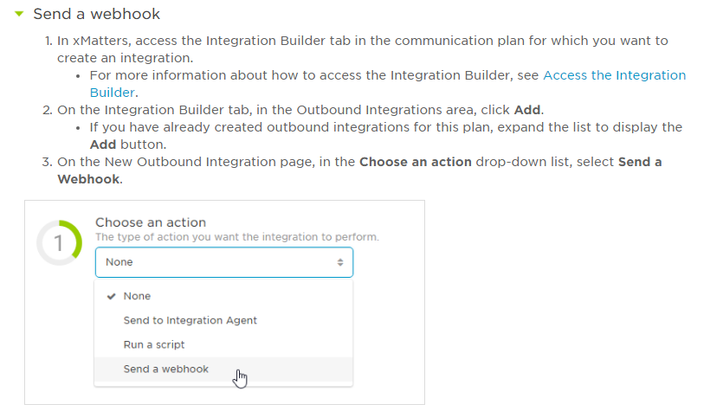

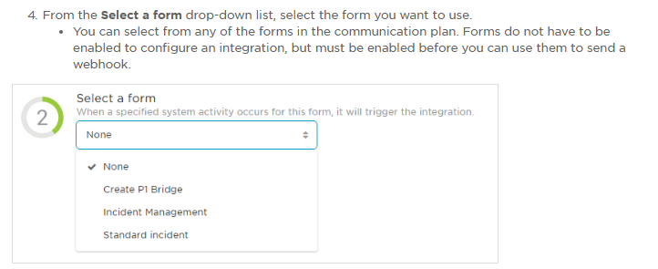

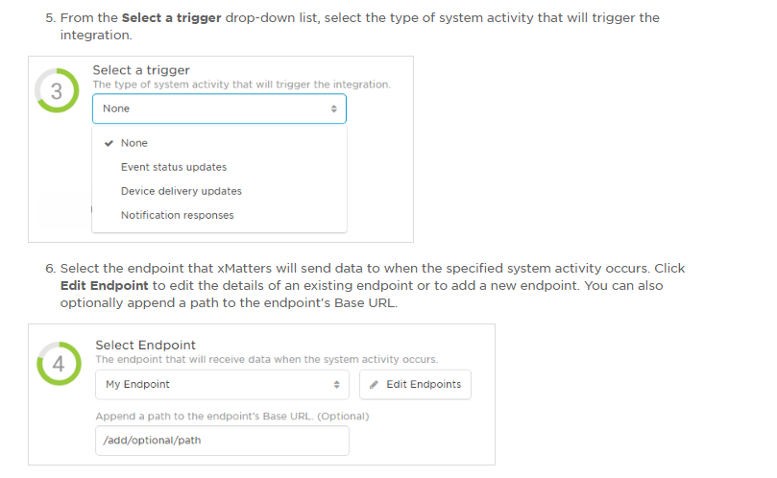

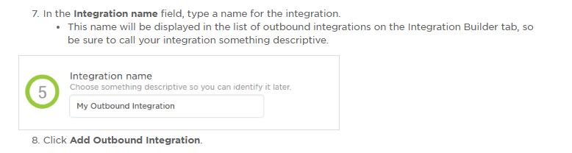

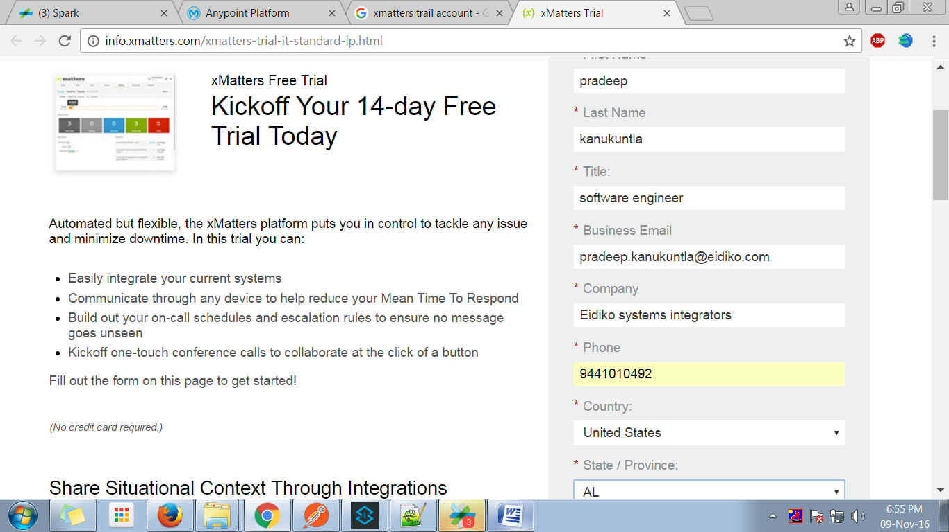

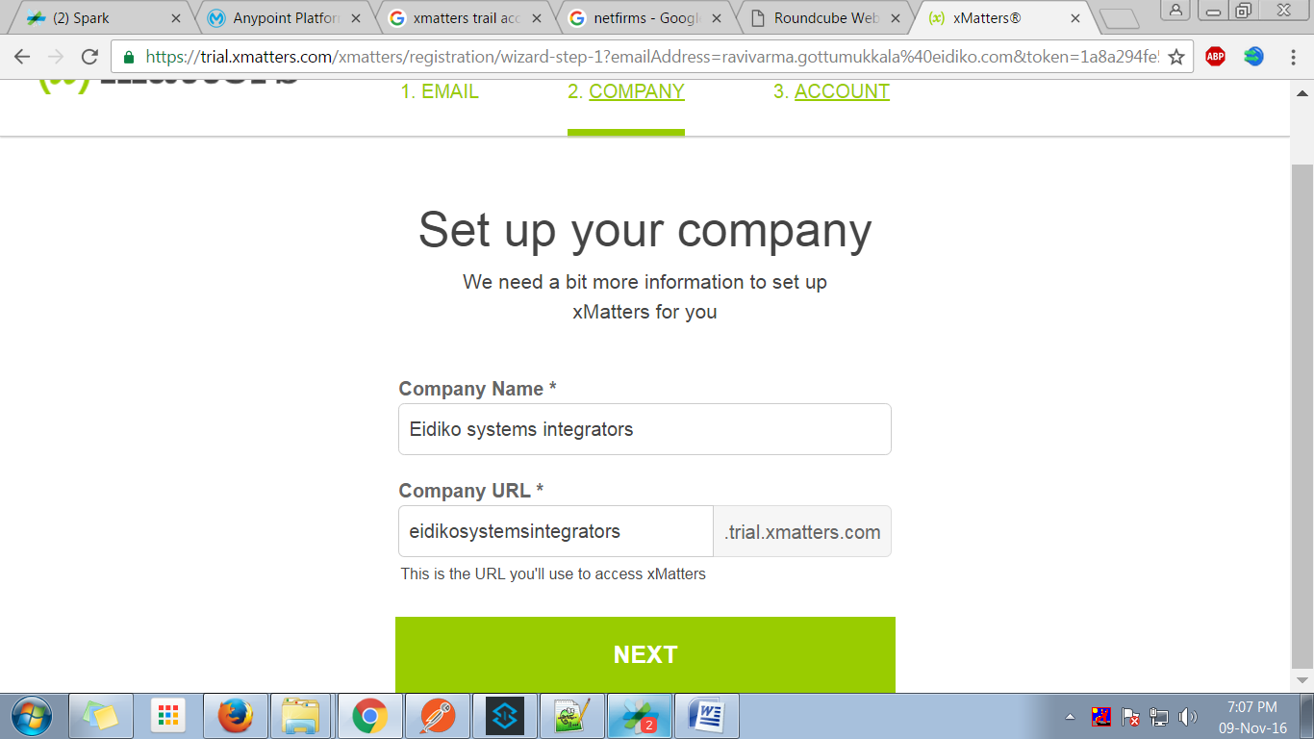

Sarasu@10

2nd

------------------

https://esi.trial.xmatters.com/xmatters/signOn.do

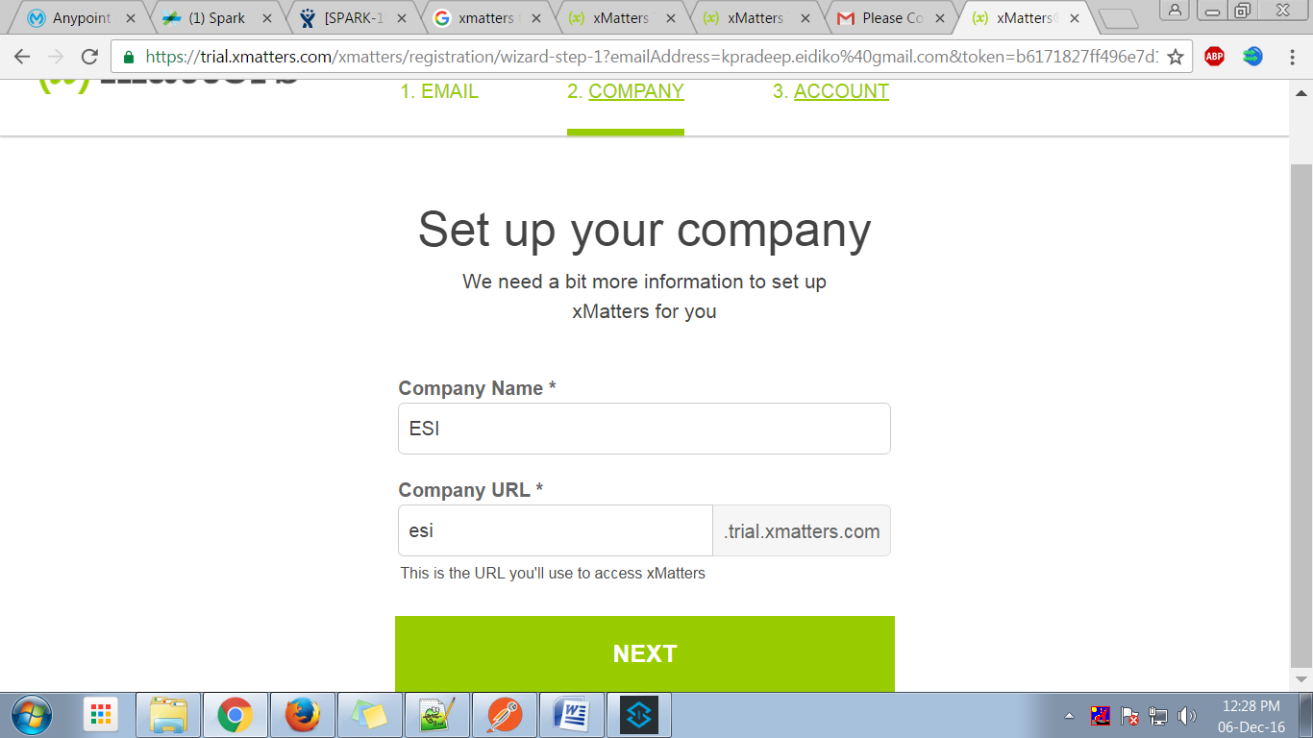

Sarasu@10

ravindra

---------------------

[https://esi1.trial.xmatters.com/xmatters/](https://esi1.trial.xmatters.com/xmatters/app.do?identifier=Tc-91T6V)signOn.do

Sarasu10

